**WEB PROGRAMING PRACTICUM REPORT**

**MODULE 6**

**PHP based web application and MySQL Database 2**



**CREATED BY :**

**KURNIAWAN BAGASKARA**

**L200214253**

**INFORMATICS STUDY PROGRAM**

**FACULTY OF COMMUNICATION AND INFORMATION SCIENCE**

**MUHAMMADIYAH SURAKARTA UNIVERSITY**

**Experiment 1**

<html>

<head><title>Data Barang</title></head>

<?php

$conn = mysqli_connect('localhost',

'root','', 'informatika');

?>

<body>

<*center*>

<h3>Masukkan Data Barang :</h3>

<table *border*='0' *width*='30%'>

<form *method*='POST' *action*='form.php'>

<tr>

<td *width*='25%'>Kode Barang</td>

<td *width*='5%'>:</td>

<td *width*='65%'><input *type*='text'

*name*='kode_barang' *size*='10'></td></tr>

<tr><td *width*='25%'>Nama Barang </td>

<td *width*='5%'>:</td>

<td *width*='65%'><input *type*='text'

*name*='nama_barang' *size*='30'></td></tr>

<tr><td *width*='25%'>Gudang</td>

<td *width*='5%'>:</td>

<td *width*='65%'>

<?php

$sql = "select * from gudang";

$retval = mysqli_query($conn,$sql);

while($row = mysqli_fetch_array($retval)){

echo "<option value='$row[kode_gudang]'>$row[nama_gudang]</option>";

}

?>

</td></tr>

</table>

<input *type*='submit' *value*='Masukkan'

*name*='submit'>

</form>

<?php

error_reporting(E_ALL ^E_WARNING^ E_NOTICE);

$kode_barang = $_POST['kode_barang'];

$nama_barang = $_POST['nama_barang'];

$kode_gudang = $_POST['kode_gudang'];

$submit = $_POST['submit'];

$input="insert into barang(kode_barang,

nama_barang, kode_gudang) values ('$kode_barang', '$nama_barang', '$kode_gudang')";

if($submit){

mysqli_query($conn,$input);

echo'</br>Data berhasil dimasukkan';

}

?>

<hr>

<H3>Data Barang</H3>

<table *border*='1' *width*='50%'>

<tr>

<td *align*='center' *width*='20%'><b>Kode

Barang</b></td>

<td *align*='center' *width*='30%'><b>Nama

Barang</b></td>

<td *align*='center' *width*='10%'><b>Lokasi

Gudang</b></td>

</tr>

<?php

$cari="select * from barang, gudang where

barang.kode_gudang = gudang.kode_gudang";

$hasil_cari=mysqli_query($conn,$cari);

while($data=mysqli_fetch_row($hasil_cari)){

echo"

<tr>

<td width='20%'>$data[0]</td>

<td width='30%'>$data[1]</td>

<td width='10%'>$data[2]</td>

</tr>";

}

?>

</table></*center*></body></html>

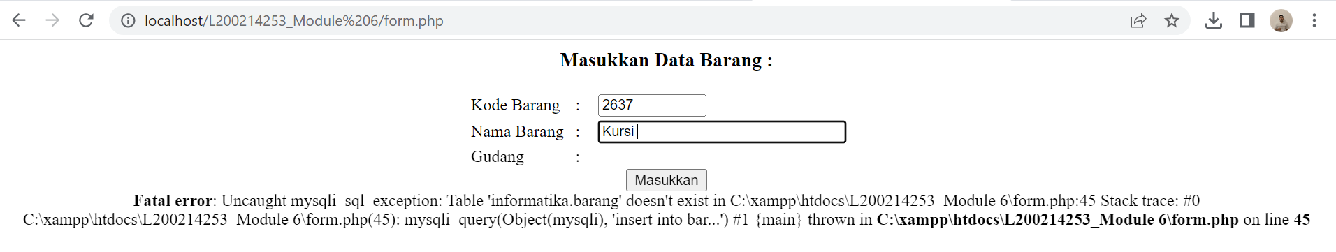

**TASK**

1. **Create a Previous Table so that it can be changed**

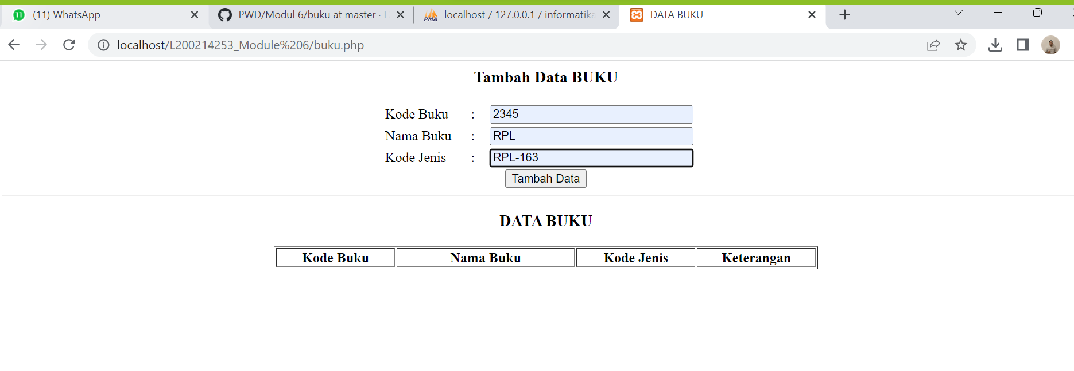

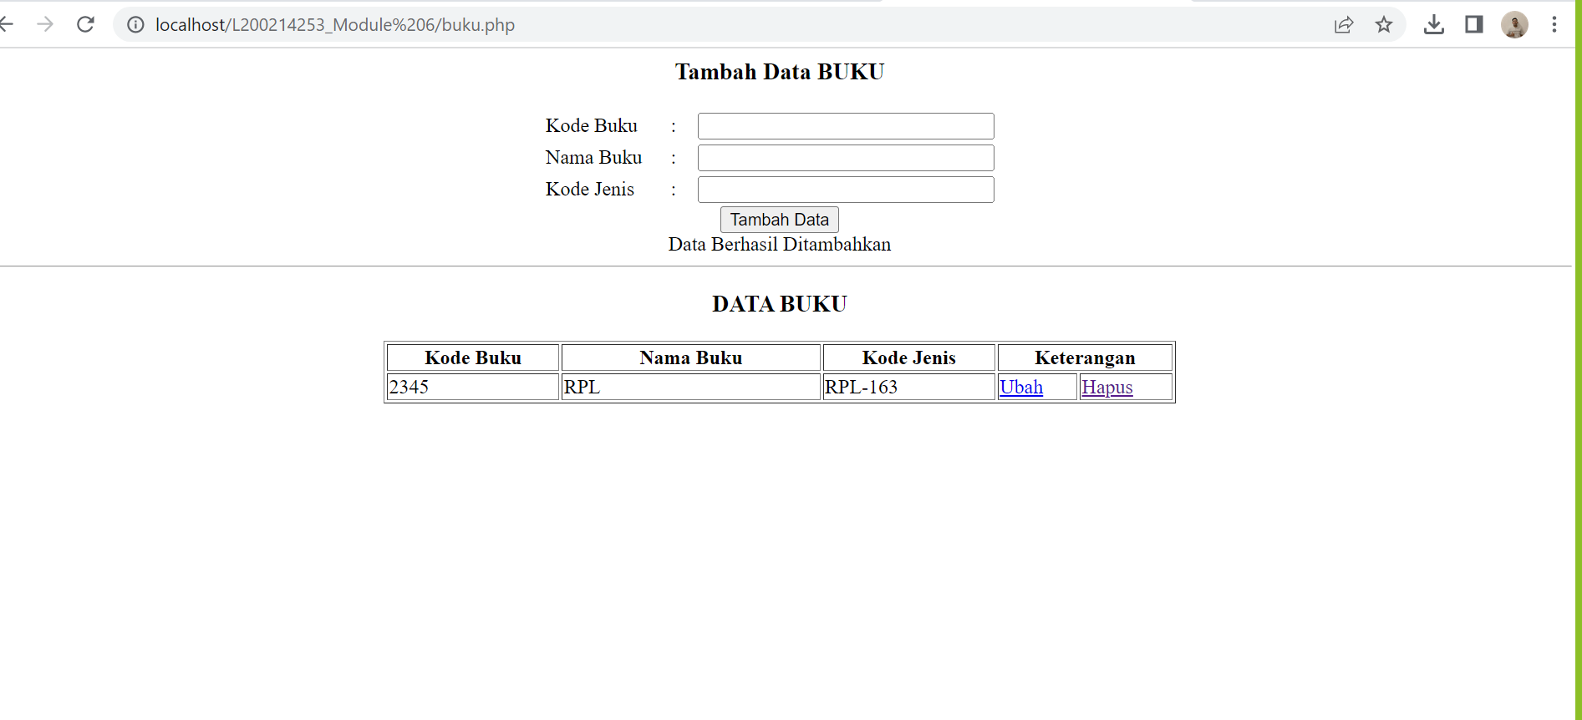

1. **Create a Warehouse table on localhost**

**Create Table BUKU**

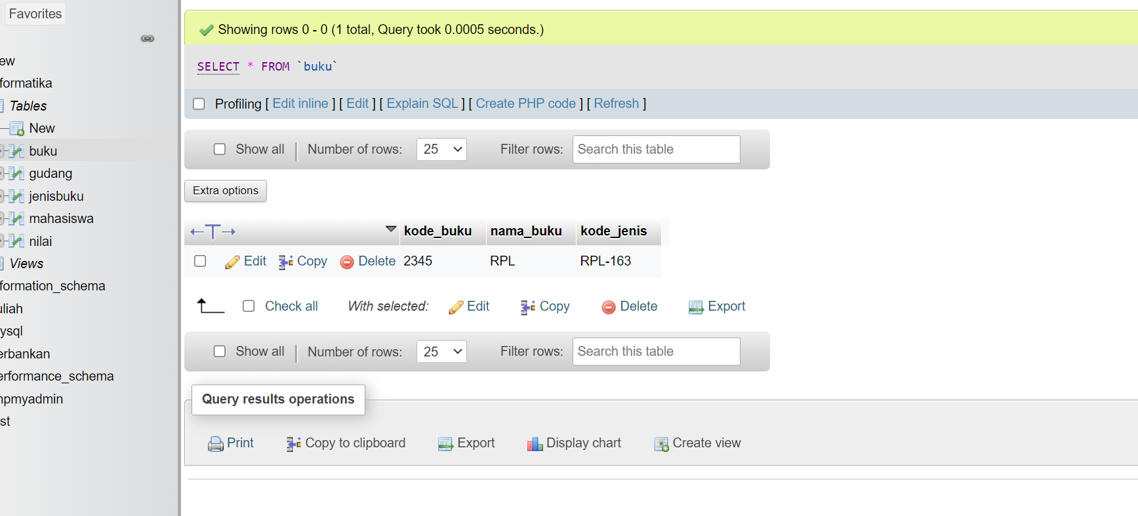

Update :

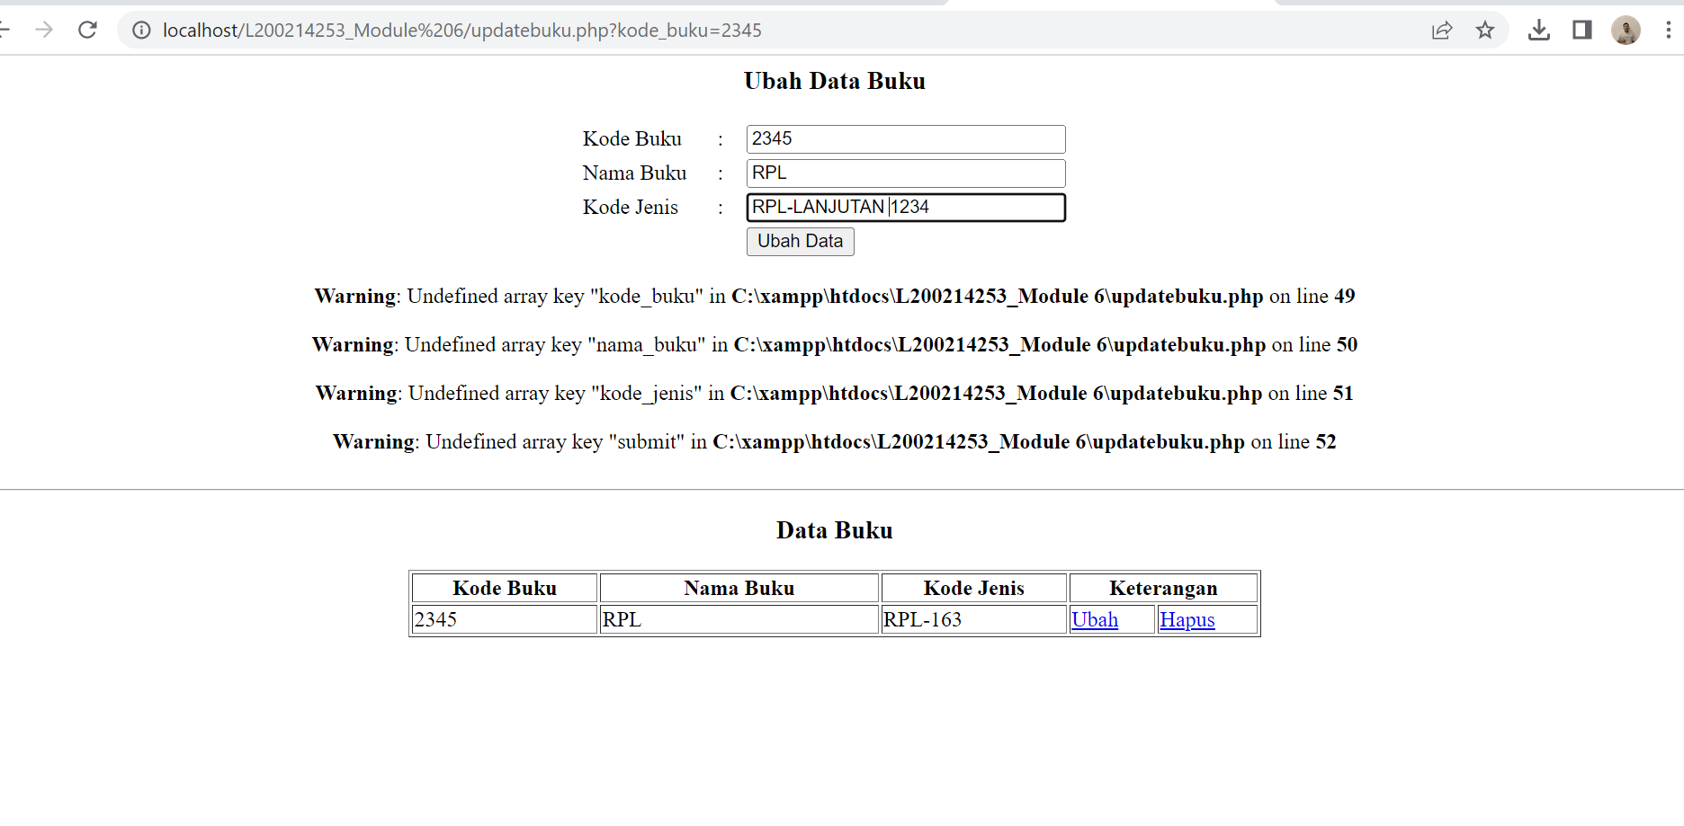

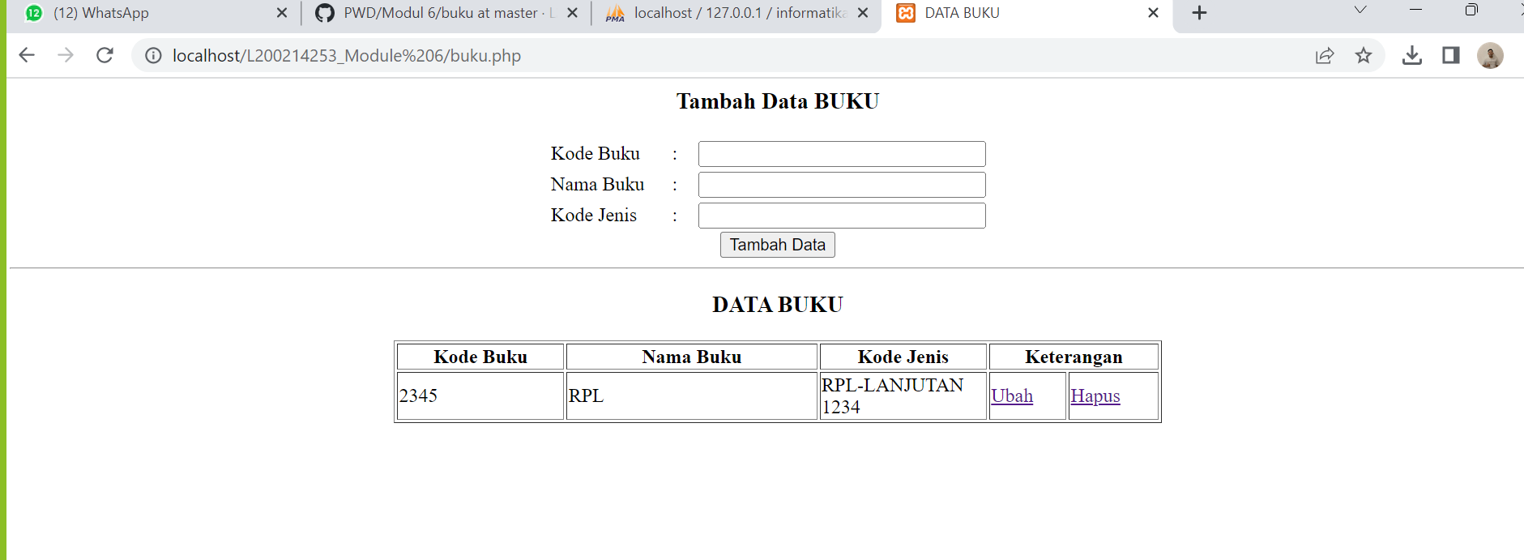

Delete:

